How to Obtain Full Text in the Ovid Discovery and PubMed Databases

Ovid
- Use the search box on the main eLibrary screen, or choose Advanced Search.
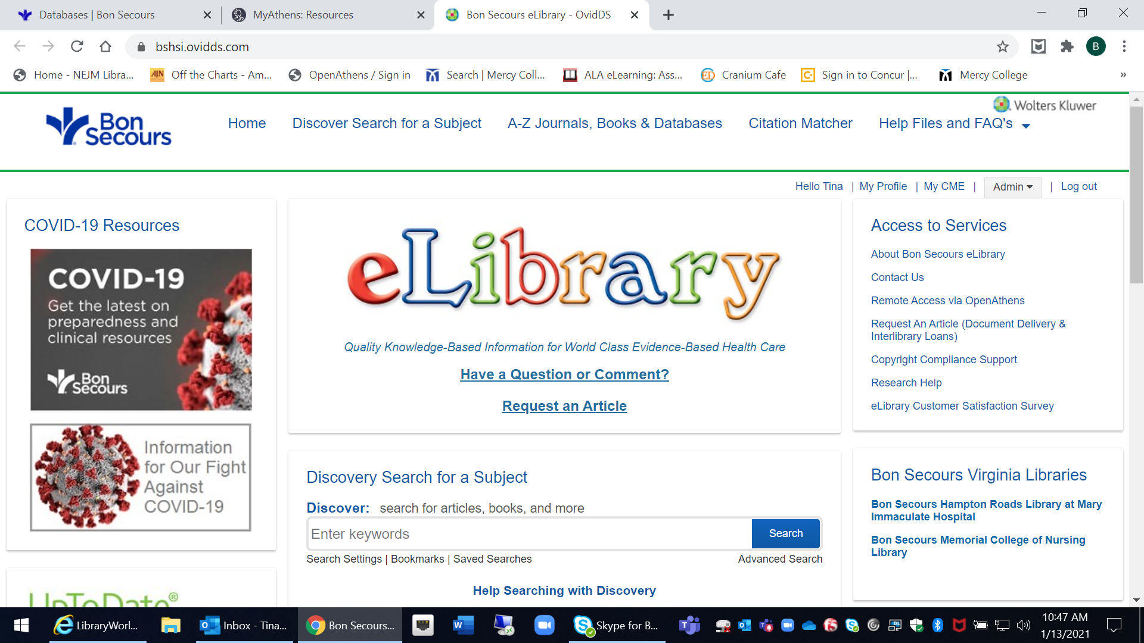

- Choose an article title from the results list.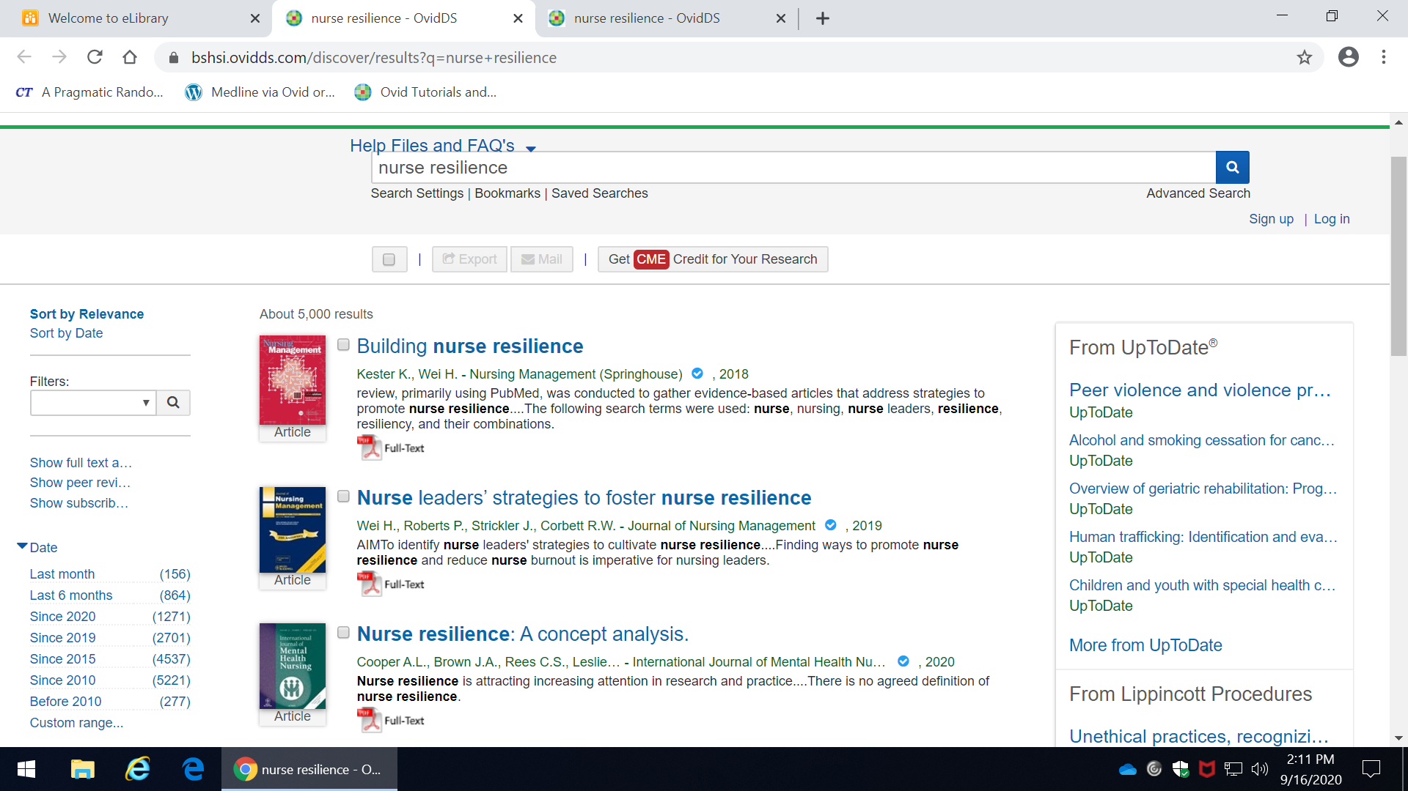
- Scroll down toward the bottom of the resulting page. Click on any Read Article button.
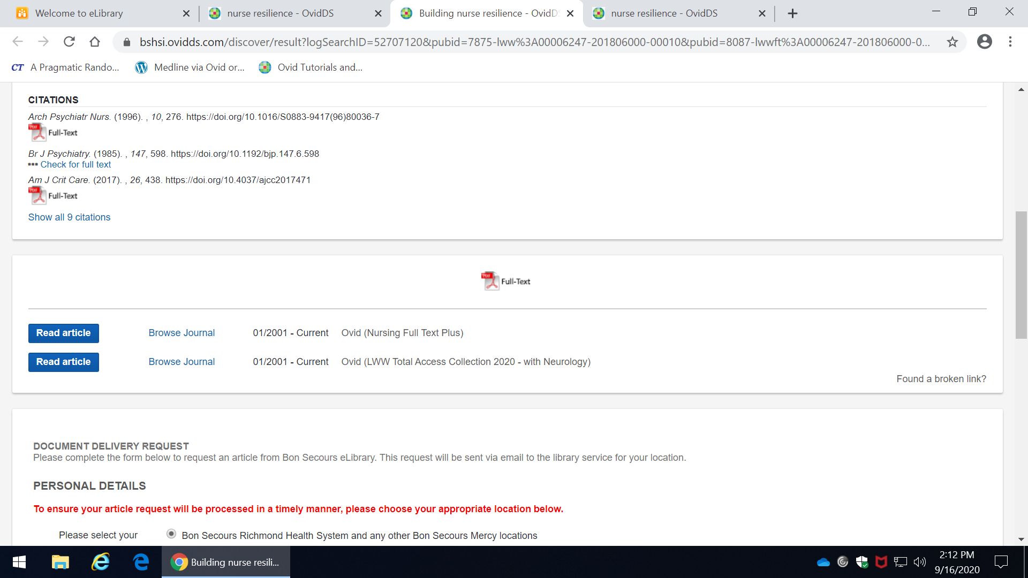
- You will often find a PDF option to click for full text.
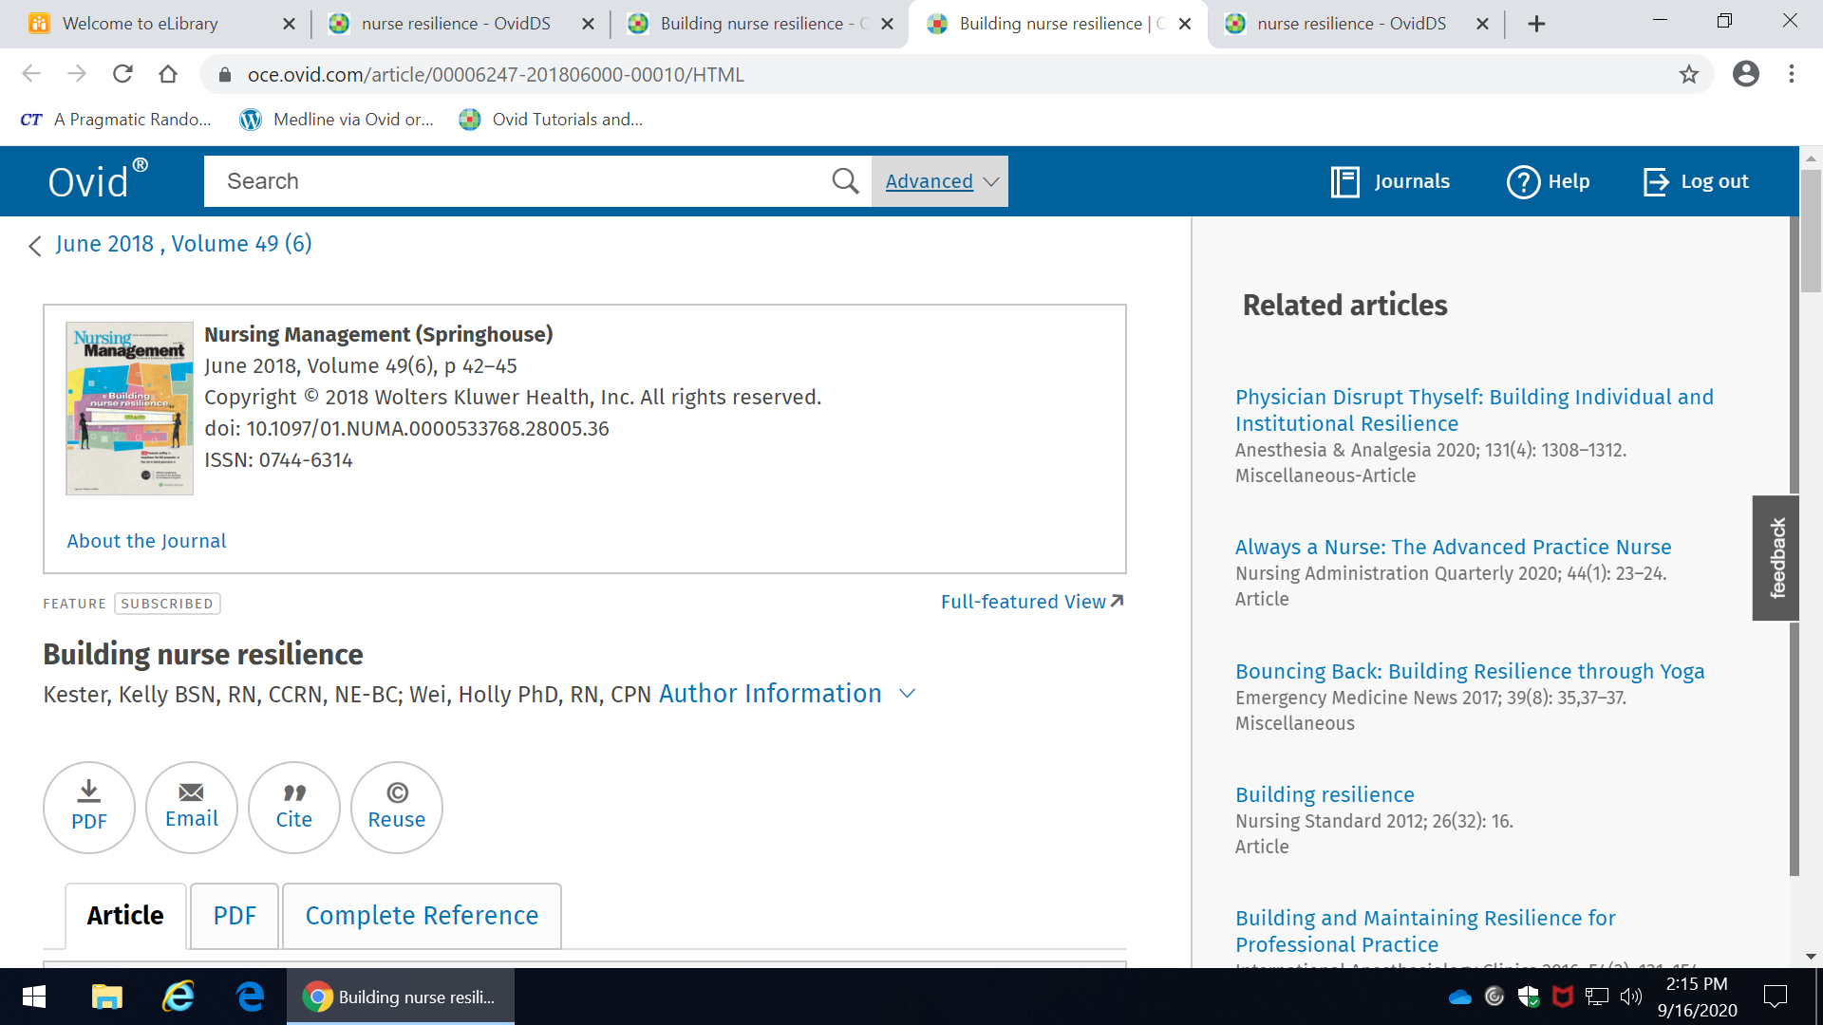
- If you do not, you can complete the Document Delivery Request form. Make sure you choose Bon Secours Memorial College of Nursing as your affiliated location.
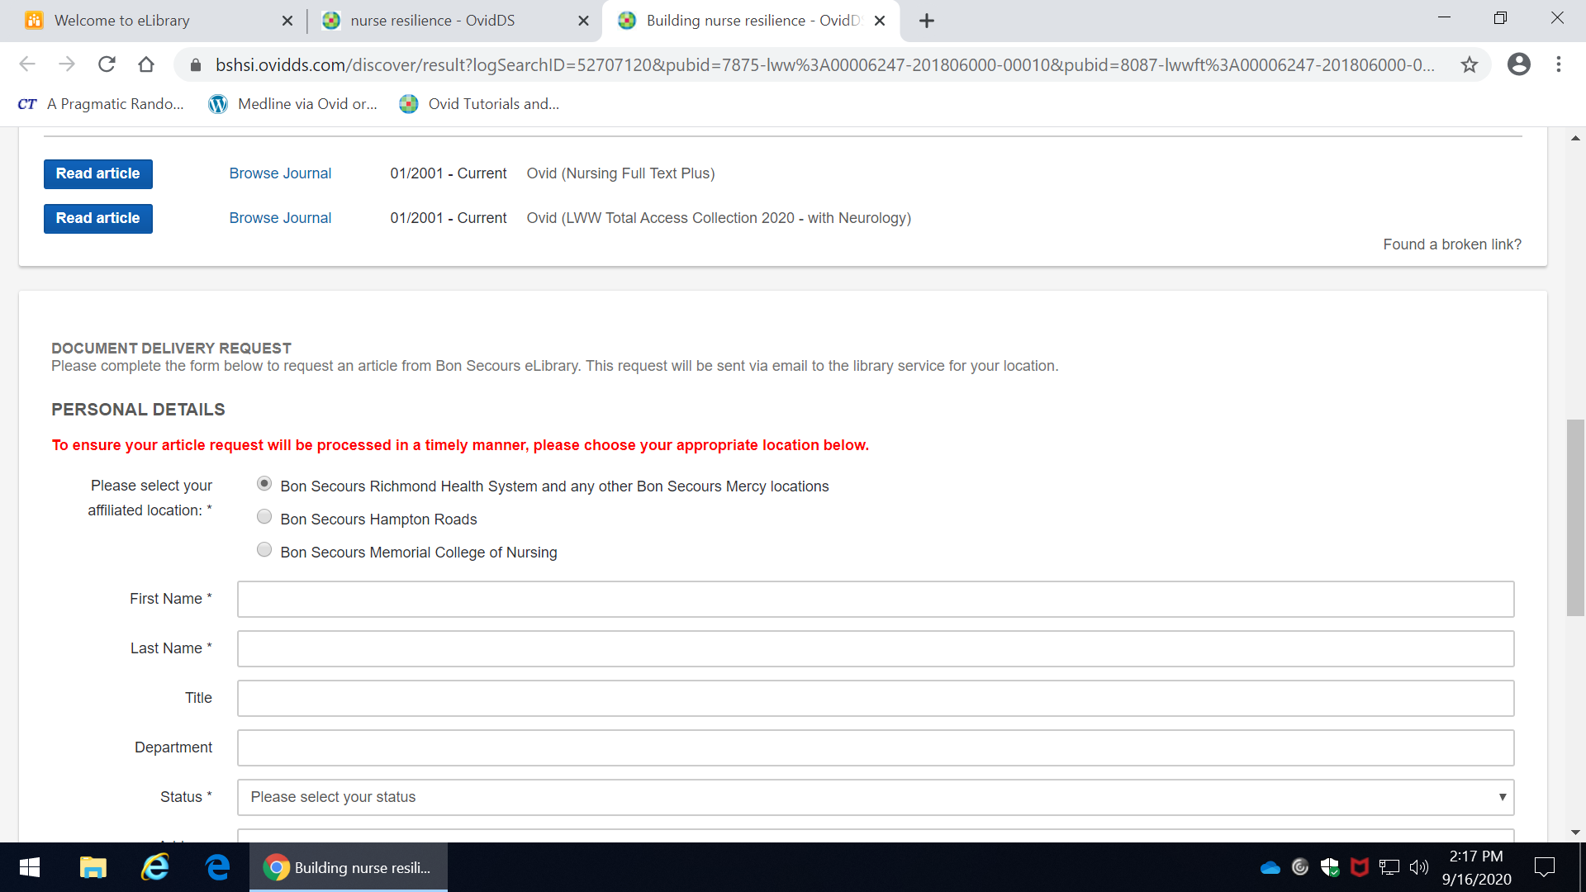
PubMed
- Enter a search term.

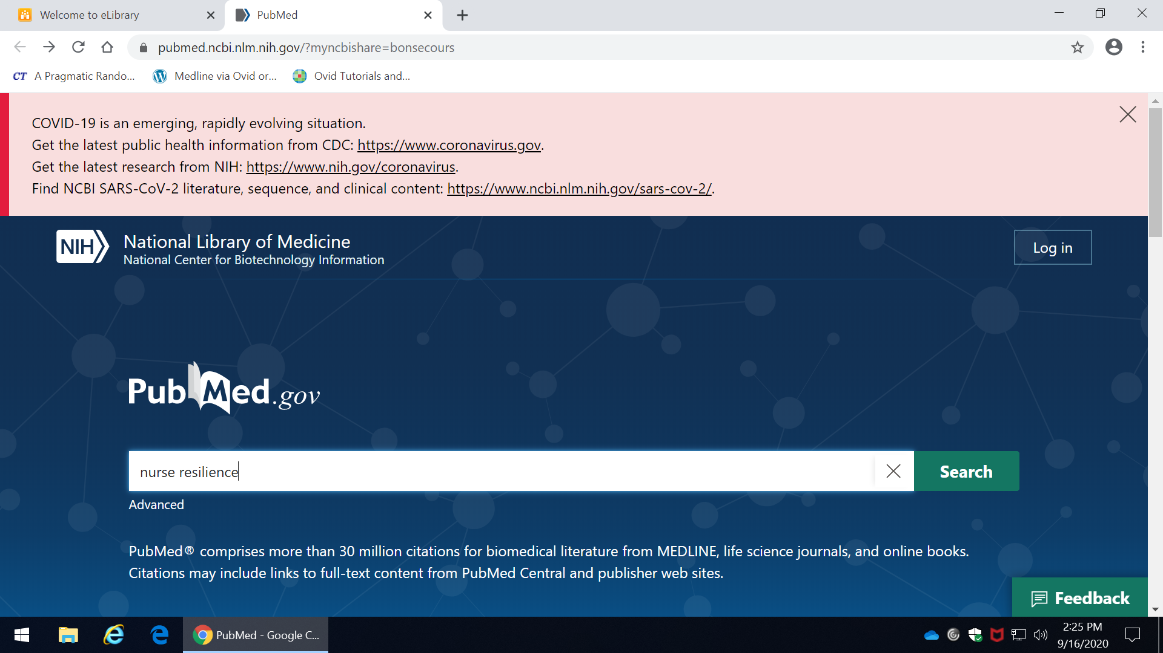

- Click on any article title. There are two places to look for full text options: in the upper right corner of the screen and at the very bottom of the screen. You can click on any icon or link you see there. If you encounter a publisher login screen and can’t get to full text, just email the article citation details to your College librarian at library@bsmcon.edu.
